T-TEST GROUPS=group(1 2)
/MISSING=ANALYSIS
/VARIABLES=frequency currentdistribution
/ES DISPLAY(TRUE)
/CRITERIA=CI(.95).

T-Test

Notes
Output Created |  | 10-MAR-2021 18:40:20
Comments
Input | Active Dataset | DataSet0
Input | Filter | <none>
Input | Weight | <none>
Input | Split File | <none>
Input | N of Rows in Working Data File | 32
Missing Value Handling | Definition of Missing | User defined missing values are treated as missing.
Missing Value Handling | Cases Used | Statistics for each analysis are based on the cases with no missing or out-of-range data for any variable in the analysis.
Syntax |  | T-TEST GROUPS=group(1 2)  /MISSING=ANALYSIS  /VARIABLES=frequency currentdistribution  /ES DISPLAY(TRUE)  /CRITERIA=CI(.95).
Resources | Processor Time | 00:00:00.02
Resources | Elapsed Time | 00:00:00.06

Group Statistics
 | group | N | Mean | Std. Deviation | Std. Error Mean
frequency | withslot | 16 | 2.6250 | .23805 | .05951
frequency | withoutslot | 16 | 2.6250 | .23805 | .05951
currentdistribution | withslot | 16 | -.409125 | .2448607 | .0612152
currentdistribution | withoutslot | 16 | -.443562 | .2259251 | .0564813

Independent Samples Test
 |  | Levene's Test for Equality of Variances |  | t-test for Equality of Means
 |  | F | Sig. | t | df
frequency | Equal variances assumed | .000 | 1.000 | .000 | 30
frequency | Equal variances not assumed |  |  | .000 | 30.000
currentdistribution | Equal variances assumed | .022 | .883 | .413 | 30
currentdistribution | Equal variances not assumed |  |  | .413 | 29.808

Independent Samples Test
 |  | t-test for Equality of Means
 |  | Sig. (2-tailed) | Mean Difference | Std. Error Difference
frequency | Equal variances assumed | 1.000 | .00000 | .08416
frequency | Equal variances not assumed | 1.000 | .00000 | .08416
currentdistribution | Equal variances assumed | .682 | .0344375 | .0832912
currentdistribution | Equal variances not assumed | .682 | .0344375 | .0832912

Independent Samples Test
 |  | t-test for Equality of Means
 |  | 95% Confidence Interval of the Difference
 |  | Lower | Upper
frequency | Equal variances assumed | -.17188 | .17188
frequency | Equal variances not assumed | -.17188 | .17188
currentdistribution | Equal variances assumed | -.1356659 | .2045409
currentdistribution | Equal variances not assumed | -.1357119 | .2045869

Independent Samples Effect Sizes
 |  | Standardizerª | Point Estimate | 95% Confidence Interval
 |  | Standardizerª | Point Estimate | Lower | Upper
frequency | Cohen's d | .23805 | .000 | -.693 | .693
frequency | Hedges' correction | .24421 | .000 | -.675 | .675
frequency | Glass's delta | .23805 | .000 | -.693 | .693
currentdistribution | Cohen's d | .2355832 | .146 | -.549 | .839
currentdistribution | Hedges' correction | .2416847 | .142 | -.535 | .818
currentdistribution | Glass's delta | .2259251 | .152 | -.545 | .845

a. The denominator used in estimating the effect sizes.
Cohen's d uses the pooled standard deviation.
Hedges' correction uses the pooled standard deviation, plus a correction factor.
Glass's delta uses the sample standard deviation of the control group.

* Chart Builder.
GGRAPH
/GRAPHDATASET NAME="graphdataset" VARIABLES=group MEANSD(frequency, 1)
MEANSD(currentdistribution, 1) MISSING=LISTWISE REPORTMISSING=NO
TRANSFORM=VARSTOCASES(SUMMARY="#SUMMARY" INDEX="#INDEX" LOW="#LOW" HIGH="#HIGH")
/GRAPHSPEC SOURCE=INLINE
/FRAME OUTER=NO INNER=NO
/GRIDLINES XAXIS=NO YAXIS=YES
/STYLE GRADIENT=NO.
BEGIN GPL
SOURCE: s=userSource(id("graphdataset"))
DATA: group=col(source(s), name("group"), unit.category())
DATA: SUMMARY=col(source(s), name("#SUMMARY"))
DATA: INDEX=col(source(s), name("#INDEX"), unit.category())
DATA: LOW=col(source(s), name("#LOW"))
DATA: HIGH=col(source(s), name("#HIGH"))
COORD: rect(dim(1,2), cluster(3,0))
GUIDE: axis(dim(3), label("group"))
GUIDE: axis(dim(2), label("Mean"))
GUIDE: legend(aesthetic(aesthetic.color.interior), label(""))
GUIDE: text.title(label("Clustered Bar Mean of frequency, Mean of currentdistribution by group ",
"by INDEX"))
GUIDE: text.footnote(label("Error Bars: 95% CI"))
GUIDE: text.subfootnote(label("Error Bars: +/- 1 SD"))
SCALE: cat(dim(3), include("1", "2"))
SCALE: linear(dim(2), include(0))
SCALE: cat(aesthetic(aesthetic.color.interior), include(
"0", "1"))
SCALE: cat(dim(1), include(
"0", "1"))
ELEMENT: interval(position(INDEX*SUMMARY*group), color.interior(INDEX),
shape.interior(shape.square))
ELEMENT: interval(position(region.spread.range(INDEX*(LOW+HIGH)*group)),
shape.interior(shape.ibeam))
END GPL.

GGraph

Notes
Output Created |  | 10-MAR-2021 18:40:56
Comments
Input | Active Dataset | DataSet0
Input | Filter | <none>
Input | Weight | <none>
Input | Split File | <none>
Input | N of Rows in Working Data File | 32
Syntax |  | GGRAPH  /GRAPHDATASET NAME="graphdataset" VARIABLES=group MEANSD(frequency, 1)  MEANSD(currentdistribution, 1) MISSING=LISTWISE REPORTMISSING=NO  TRANSFORM=VARSTOCASES(SUMMARY="#SUMMARY" INDEX="#INDEX" LOW="#LOW" HIGH="#HIGH")  /GRAPHSPEC SOURCE=INLINE  /FRAME OUTER=NO INNER=NO  /GRIDLINES XAXIS=NO YAXIS=YES  /STYLE GRADIENT=NO.  BEGIN GPL  SOURCE: s=userSource(id("graphdataset"))  DATA: group=col(source(s), name("group"), unit.category())  DATA: SUMMARY=col(source(s), name("#SUMMARY"))  DATA: INDEX=col(source(s), name("#INDEX"), unit.category())  DATA: LOW=col(source(s), name("#LOW"))  DATA: HIGH=col(source(s), name("#HIGH"))  COORD: rect(dim(1,2), cluster(3,0))  GUIDE: axis(dim(3), label("group"))  GUIDE: axis(dim(2), label("Mean"))  GUIDE: legend(aesthetic(aesthetic.color.interior), label(""))  GUIDE: text.title(label("Clustered Bar Mean of frequency, Mean of currentdistribution by group ",  "by INDEX"))  GUIDE: text.footnote(label("Error Bars: 95% CI"))  GUIDE: text.subfootnote(label("Error Bars: +/- 1 SD"))  SCALE: cat(dim(3), include("1", "2"))  SCALE: linear(dim(2), include(0))  SCALE: cat(aesthetic(aesthetic.color.interior), include(  "0", "1"))  SCALE: cat(dim(1), include(  "0", "1"))  ELEMENT: interval(position(INDEX*SUMMARY*group), color.interior(INDEX),  shape.interior(shape.square))  ELEMENT: interval(position(region.spread.range(INDEX*(LOW+HIGH)*group)),  shape.interior(shape.ibeam))  END GPL.
Resources | Processor Time | 00:00:00.47
Resources | Elapsed Time | 00:00:00.27

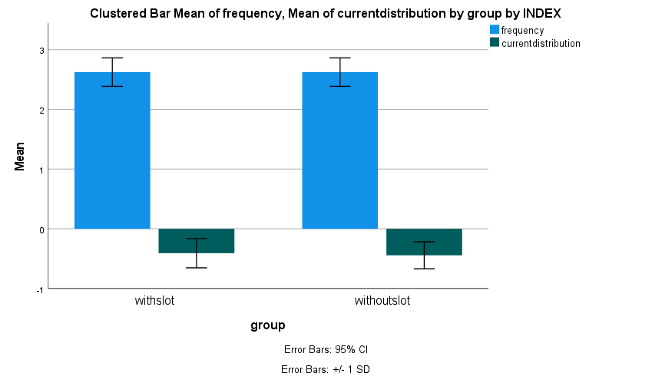

DATASET ACTIVATE DataSet0.
DATASET ACTIVATE DataSet0.

SAVE OUTFILE='E:\final year projects\circular patch 2.4GHz projects\project2\spss '+
'graph\DataSet0.sav'
/COMPRESSED.
DATASET ACTIVATE DataSet0.

